MLA0105-ARTIFICIAL INTELLIGENCE AND EXPERT SYSTEMS

NAME: N.MD.Sadhiq (192425136)

1.SLIDING PUZZLE:
import heapq

# Define the goal state
goal_state = [[1, 2, 3],
[4, 5, 6],
[7, 8, 0]]

# Heuristic function: Manhattan distance
def heuristic(state):
d = 0
for i in range(3):
for j in range(3):
value = state[i][j]
if value != 0:
x, y = divmod(value-1, 3)
d += abs(x-i) + abs(y-j)
return d

# Find the position of the empty tile (0)
def find_zero(state):
for i in range(3):
for j in range(3):
if state[i][j] == 0:
return i, j

# Move the empty tile in valid directions
def get_neighbors(state):
zero_x, zero_y = find_zero(state)
neighbors = []
directions = [(-1,0),(1,0),(0,-1),(0,1)]
for dx, dy in directions:
x, y = zero_x + dx, zero_y + dy
if 0 <= x < 3 and 0 <= y < 3:
new_state = [row[:] for row in state]
new_state[zero_x][zero_y], new_state[x][y] = new_state[x][y], new_state[zero_x][zero_y]
neighbors.append(new_state)
return neighbors

# A* algorithm
def solve(start_state):
start_tuple = tuple(tuple(row) for row in start_state)
goal_tuple = tuple(tuple(row) for row in goal_state)

pq = [(heuristic(start_state), 0, start_state, [])]
visited = set()

while pq:
est, cost, state, path = heapq.heappop(pq)
state_tuple = tuple(tuple(row) for row in state)

if state_tuple in visited:
continue
visited.add(state_tuple)

if state_tuple == goal_tuple:
return path + [state]

for neighbor in get_neighbors(state):
heapq.heappush(pq, (cost + 1 + heuristic(neighbor), cost + 1, neighbor, path + [state]))

return None

# Example scrambled state from the image:
start_state = [[1, 6, 5],
[7, 3, 8],
[0, 4, 2]]

solution = solve(start_state)
if solution:
for step in solution:
for row in step:
print(row)
print("-----")
else:
print("No solution found.")

OUTPUT:
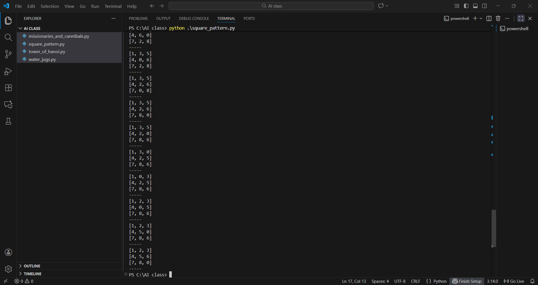

2. The Towers of Hanoi:
def towers_of_hanoi(n, source, auxiliary, target):
if n == 1:
print(f"Move disk 1 from {source} to {target}")
return
towers_of_hanoi(n - 1, source, target, auxiliary)
print(f"Move disk {n} from {source} to {target}")
towers_of_hanoi(n - 1, auxiliary, source, target)

# Example usage:
n = 3 # Number of disks, you can change this value
towers_of_hanoi(n, 'A', 'B', 'C')
print(towers_of_hanoi)
OUTPUT:
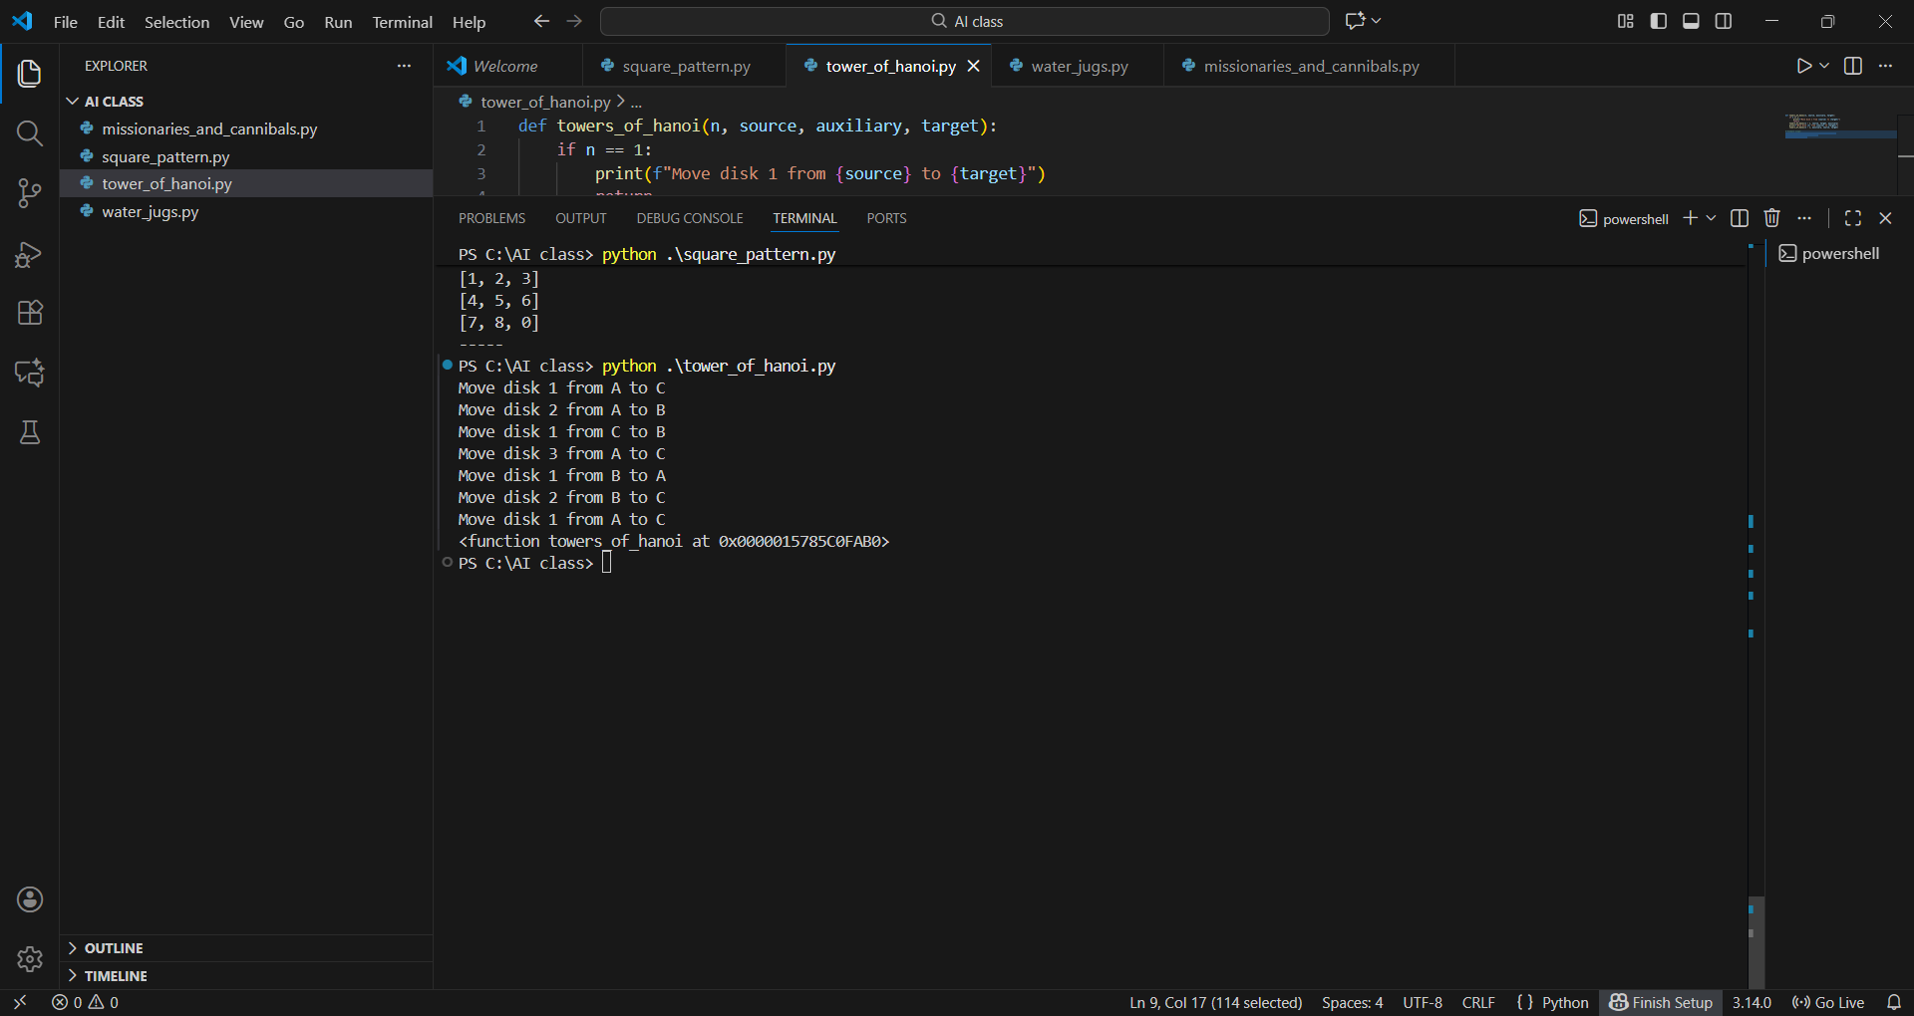

3.BFS:
from collections import deque

def bfs(graph, start):
visited = set()
queue = deque([start])
visited.add(start)

while queue:
node = queue.popleft()
print(node, end=" ")

for neighbor in graph[node]:
if neighbor not in visited:
visited.add(neighbor)
queue.append(neighbor)

# Example usage:
graph = {
'A': ['B', 'C'],
'B': ['A', 'D', 'E'],
'C': ['A', 'F'],
'D': ['B'],
'E': ['B', 'F'],
'F': ['C', 'E']
}

start_node = 'A'
bfs(graph, start_node)
OUTPUT:
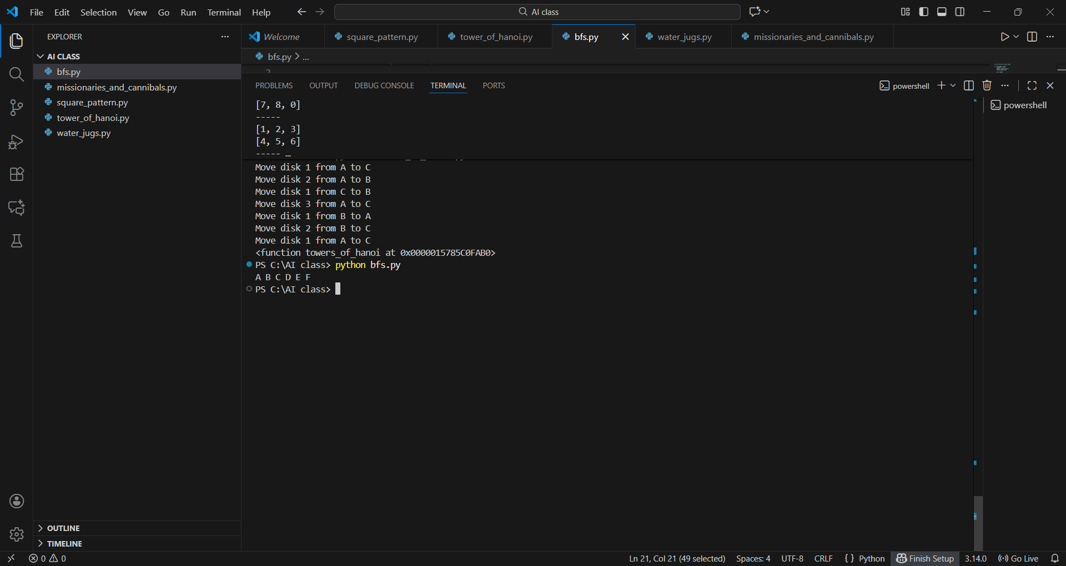

4.MONKEY AND BANANA
from collections import deque

# State is represented as a tuple:
# (monkey_position, box_position, bananas_position, monkey_has_bananas)
# Positions: 'left', 'middle', 'right'

def is_goal(state):
# Goal is when monkey has bananas
return state[3] == True

def get_actions(state):
monkey_pos, box_pos, bananas_pos, has_bananas = state
actions = []

# Monkey can move alone
for pos in ['left', 'middle', 'right']:
if pos != monkey_pos:
actions.append(('move', pos))
# Monkey can push box if at same position as box and move box to adjacent position
for pos in ['left', 'middle', 'right']:
if pos != box_pos:
if monkey_pos == box_pos and (abs(pos_index(pos) - pos_index(box_pos)) == 1):
actions.append(('push', pos))
# Monkey can climb box if monkey and box are at same position
if monkey_pos == box_pos:
actions.append(('climb',))
# Monkey can grab bananas if monkey on box at bananas position
# For simplicity, we consider monkey 'on box' means monkey and box same position and monkey climbed
# We track if monkey has bananas in state already, so only action is grab when aligned
if monkey_pos == box_pos == bananas_pos:
actions.append(('grab',))

return actions

def pos_index(pos):
return {'left':0, 'middle':1, 'right':2}[pos]

def apply_action(state, action):
monkey_pos, box_pos, bananas_pos, has_bananas = state

if action[0] == 'move':
# Monkey moves alone
return (action[1], box_pos, bananas_pos, has_bananas)
elif action[0] == 'push':
# Monkey pushes box
new_pos = action[1]
return (new_pos, new_pos, bananas_pos, has_bananas)
elif action[0] == 'climb':
# For this simple model, climbing doesn't change position, just a required action before grabbing
return (monkey_pos, box_pos, bananas_pos, has_bananas)
elif action[0] == 'grab':
# Monkey grabs bananas
return (monkey_pos, box_pos, bananas_pos, True)
return state

def monkey_and_banana():
initial_state = ('left', 'middle', 'right', False)
queue = deque()
queue.append((initial_state, []))
visited = set()

while queue:
state, path = queue.popleft()
if state in visited:
continue
visited.add(state)

if is_goal(state):
return path + [state]

for action in get_actions(state):
new_state = apply_action(state, action)
queue.append((new_state, path + [(state, action)]))
return None

solution = monkey_and_banana()
if solution:
for step in solution[:-1]:
state, action = step
print(f"At state {state}, do action {action}")
print(f"Goal reached at state {solution[-1]}")
else:
print("No solution found.")
OUTPUT:
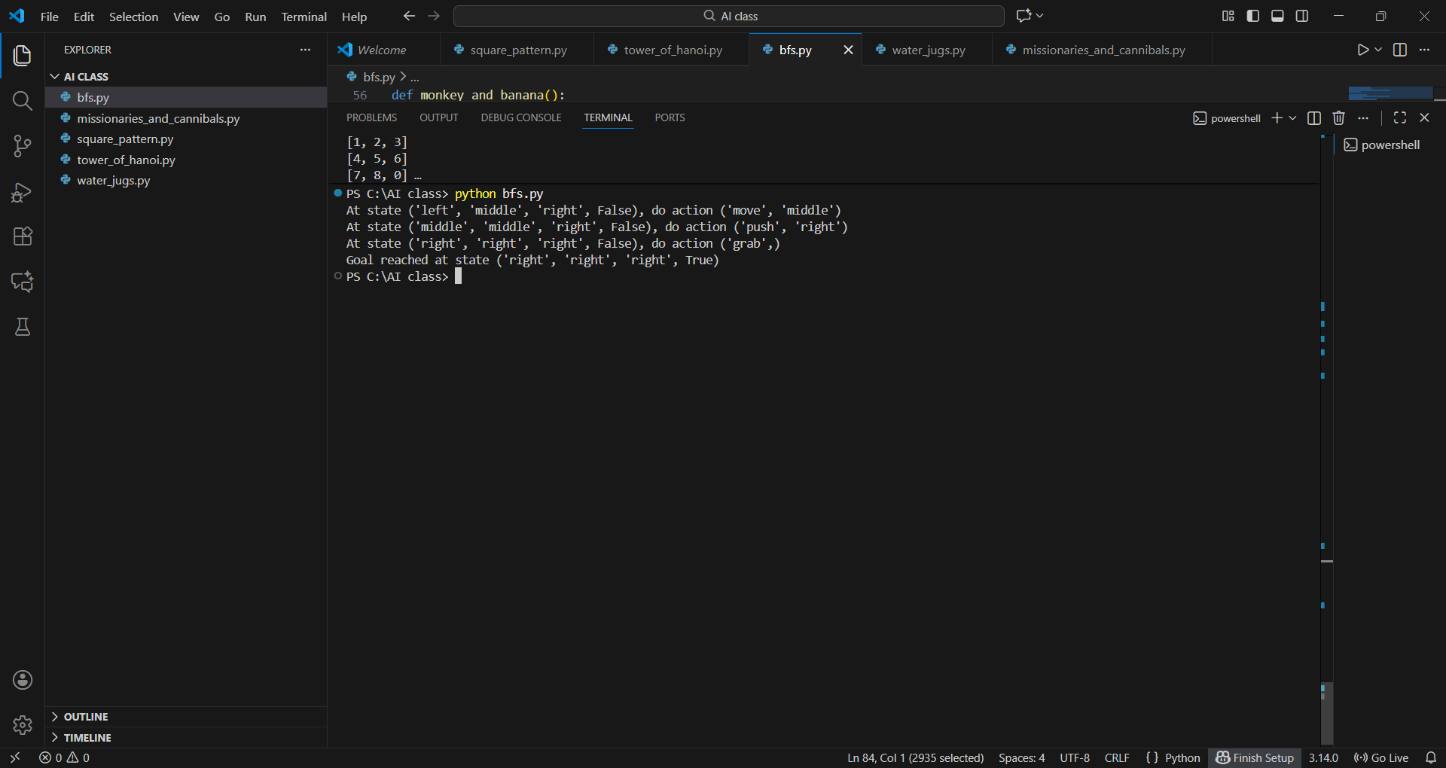

5. CHESS BOARD
def is_safe(board, row, col):
# Check this row on left side
for i in range(col):
if board[row][i] == 1:
return False

# Check upper diagonal on left side
for i, j in zip(range(row,-1,-1), range(col,-1,-1)):
if board[i][j] == 1:
return False

# Check lower diagonal on left side
for i, j in zip(range(row, len(board), 1), range(col,-1,-1)):
if board[i][j] == 1:
return False

return True

def solve_nqueens_util(board, col):
if col >= len(board):
return True

for i in range(len(board)):
if is_safe(board, i, col):
board[i][col] = 1
if solve_nqueens_util(board, col + 1):
return True
board[i][col] = 0 # Backtrack

return False

def print_board(board):
for row in board:
print(' '.join('Q' if x else '.' for x in row))

def solve_nqueens():
N = 8
board = [[0 for _ in range(N)] for _ in range(N)]
if not solve_nqueens_util(board, 0):
print("No solution exists")
return
print_board(board)

solve_nqueens()

OUTPUT:
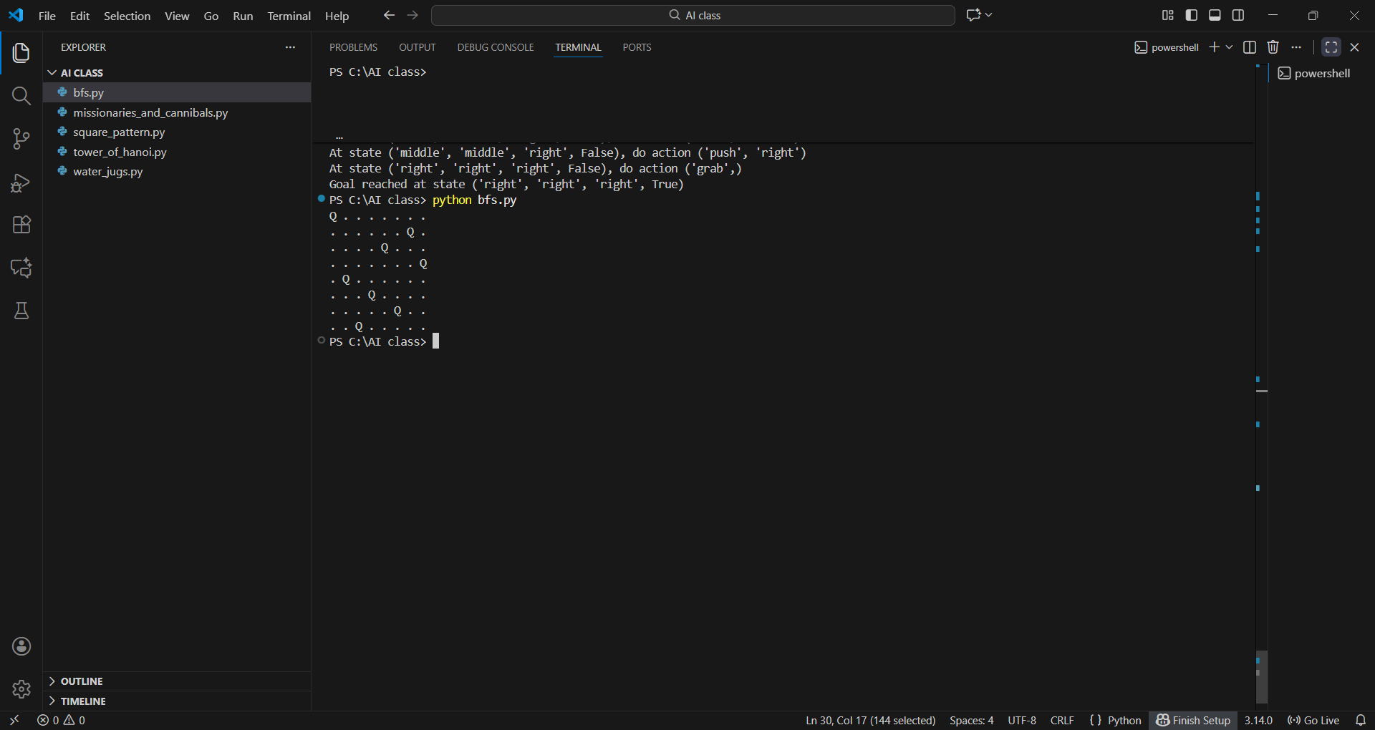

6.DFS
def dfs(graph, node, visited=None):
if visited is None:
visited = set()
if node not in visited:
print(node, end=" ") # Print the node as soon as it is visited
visited.add(node)
for neighbor in graph[node]:

dfs(graph, neighbor, visited)

# Example graph (matches the typical structure in your image)
graph = {
5: [3, 7],
3: [2, 4],
2: [],
4: [8],
7: [8],
8: []
}

start_node = 5
dfs(graph, start_node)

OUTPUT: 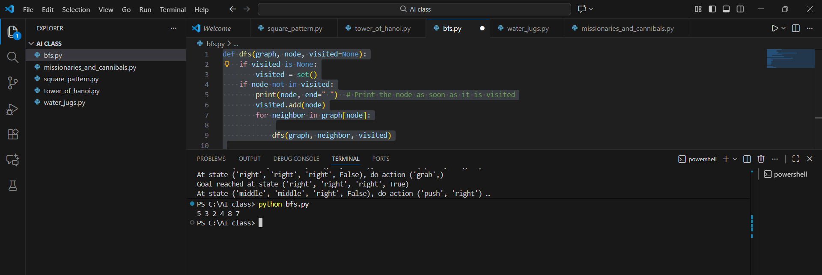

7.WATER JUGS:
from collections import deque

def water_jug_bfs():
# (amount in 4-gal jug, amount in 3-gal jug)
initial_state = (0, 0)
goal_state = (2, 0)
# Keep track of visited states to avoid cycles
visited = set()
# Each item in queue: (state, path history)
queue = deque([(initial_state, [])])

while queue:
(a, b), path = queue.popleft()

if (a, b) in visited:
continue
visited.add((a, b))

# Check if we have the required solution
if a == 2:
return path + [(a, b)]

# Generate all possible next moves
possible_moves = [
((4, b), "Fill 4-gal jug from pump"),
((a, 3), "Fill 3-gal jug from pump"),
((0, b), "Empty 4-gal jug on ground"),
((a, 0), "Empty 3-gal jug on ground"),
# Pour from 4-gal to 3-gal
( (a - min(a, 3-b), b + min(a, 3-b)), "Pour 4-gal into 3-gal"),
# Pour from 3-gal to 4-gal
( (a + min(b, 4-a), b - min(b, 4-a)), "Pour 3-gal into 4-gal"),
]

for (next_a, next_b), action in possible_moves:
if (next_a, next_b) not in visited:
queue.append( ((next_a, next_b), path + [(a, b, action)] ))

return None

solution = water_jug_bfs()
if solution:
for step in solution:
if len(step) == 3:
print(f"{step[2]} -> State: (4-gal={step[0]}, 3-gal={step[1]})")
else:
print(f"Final State: (4-gal={step[0]}, 3-gal={step[1]})")
else:
print("No solution found.")

output:
